Manufacturing for an Inductive Charging Component of the Unmanned Aerial Vehicle (UAV) and Quadcopter

Chandler Duncan, Kaiqi Luo, Sophoandara Ry, Mumen Abbas, Peter Ayad
Department of Electrical & Computer Engineering
California State Polytechnic University, Pomona, CA USA
Abstract
Problem Identification: There are severe limitations to drone flight endurance due to factors including load/weight capacity and battery performance. Our team is responsible for creating the inductive charging component of the unmanned aerial vehicle (UAV) and quadcopter. Our goal is to extend the longevity of each respective vehicles’ flight time by utilizing a form of wireless power transfer mid-flight.
Approach of This Project: Our primary focus has been the production of a receiver, whose function is to receive and process energy that is stored within its magnetic field. Since we know that transmission lines have a constant current travelling through them, we know they produce a magnetic field, and the receiver on the UAV will be able to draw power from these magnetic fields via inductive charging. The manufacturing team has created multiple induction coils for the receivers of both the UAV and the quadcopter, with each coil varying in size or number of coils, in order to experiment with the inductance value. To test this wireless charging technologies, the quadcopter UAV is used for demonstrating and testing purpose.
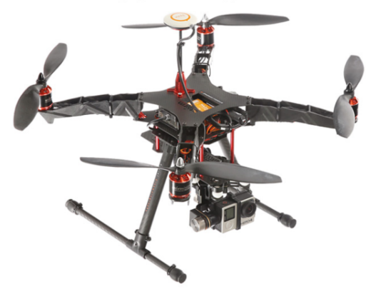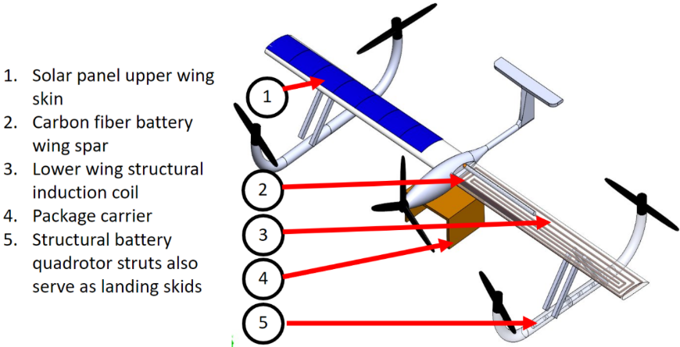
Fig.1: Quadcopter Fig.2: SINCHDrone UAV
The receiver coils have a voltage/current induced within them via their magnetic field, which then travels through the receiver and power management circuits, thus recharging the system. With this design in place, the UAV should ideally be able to fly for an indefinite amount while travelling within charging distance of the transmission lines.
Our second receiver is being designed for the quadcopter, which will work complementary to a manufactured ground station. The ground station, which consists of a transmitter circuit, will be able to transfer power wirelessly from the ground to the quadcopter mid-flight. The ground station will transfer power to the quadcopter using mutual induction, which involves the transmitter and receiver consisting of two identical inductance coils. After verifying the tests for the wireless charging demonstrations, the final phase will include bonding induction coils to the fiber class lower wing skin and fully integrated testbed for the SINCHDrone UAV. Bonding induction coils will help producing additional power for the power management system, as shown in the Fig.2 above.
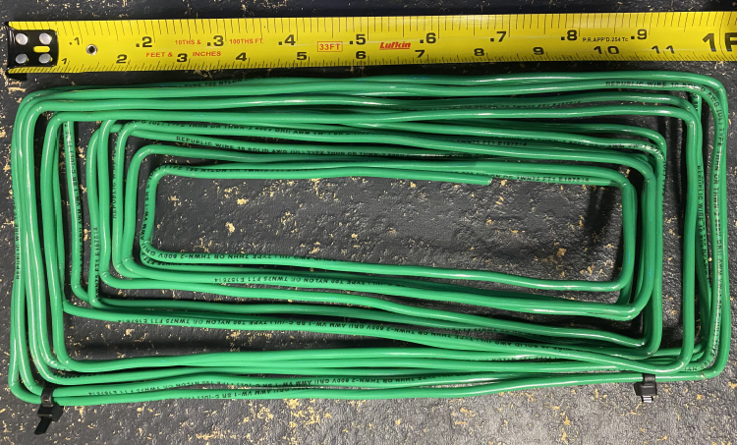
Fig.3: SINCHDrone UAV induction-wing coils.
How Do We Consider this Project Successful: If we are able to provide consistent charging to the UAV, to the extent it is able to continuously operate without the need to land and charge, then this project can be considered a success. Similarly, the ground station would see success if the quadcopter were able to receive continuous charging while within close proximity to the ground station.
How Your Results Will Impact the World: While much of this work is only preliminary experimentation and test of theory, the potential applications of this technology can be greatly utilized. In instances of natural disasters, where humans are unable to reach specific locations, drones could be utilized to continuously conduct search efforts for extended periods of time. These drones could also be used by everyday utility companies to more efficiently inspect poles and transmission towers on a regular basis. The ground station technology could be scaled up one day to wirelessly charge drones from a much farther distance.

